Probabilistic Decline Curve Analysis Report

# 1. Overview

This report summarizes the results of the probabilistic decline curve analysis, including data cleaning, Monte Carlo sampling, model fitting, hindcast testing, and EUR analysis.

# 2. Initial Production Data & LOF Outlier Detection

## Initial Production Data with LOF Outlier Detection

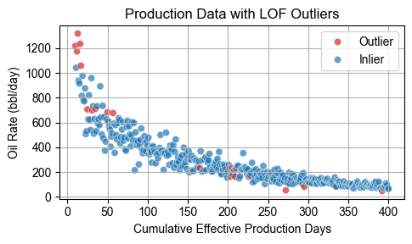

# 3. Monte Carlo Sampling

## Monte Carlo Sampling Distribution

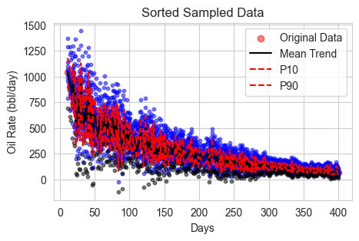

# 4. Model Training Fit

## Training Fit — ARPS

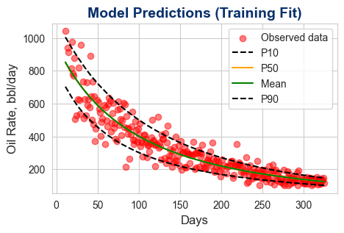

## Training Fit — SEM

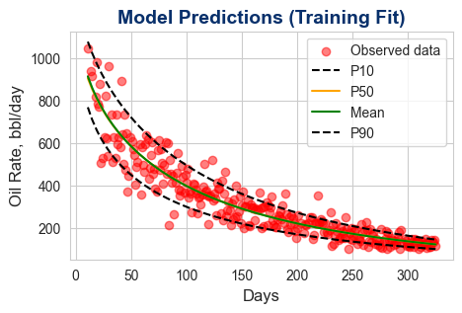

## Training Fit — CRM

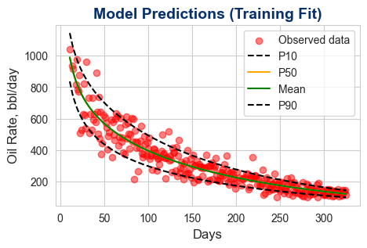

## Training Fit — LGM

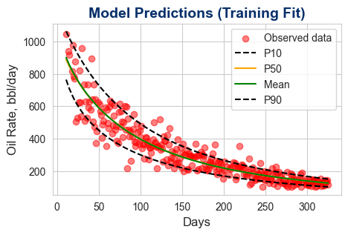

# 5. Marginal Posterior Probabilities of Models

## Model Posterior Probabilities

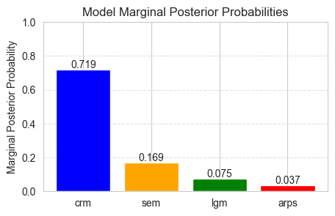

# 6. Hindcast Test

## Hindcast Test — ARPS

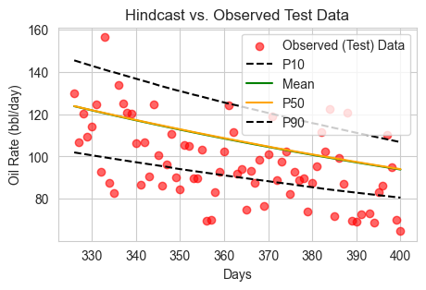

## Hindcast Test — SEM

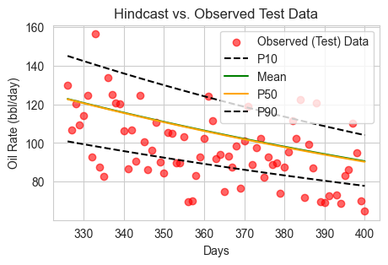

## Hindcast Test — CRM

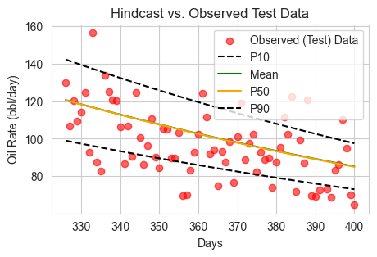

## Hindcast Test — LGM

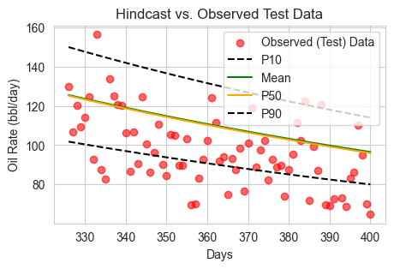

# 7. Model-Specific EUR Statistics

## Per Model EUR Summary

|  |  |  |  |  |
| --- | --- | --- | --- | --- |
| Model | p10 | p50 | mean | p90 |
| arps | 151,596 | 160,734 | 162,664 | 177,200 |
| sem | 139,413 | 140,735 | 141,913 | 145,638 |
| crm | 131,511 | 131,795 | 132,188 | 132,811 |
| lgm | 162,863 | 164,999 | 166,458 | 172,448 |

# 8. Combined EUR Statistics

## Combined EUR Summary

|  |  |  |  |  |  |
| --- | --- | --- | --- | --- | --- |
| p10 | p25 | p50 | p75 | p90 | mean |
| 132,755 | 133,050 | 134,373 | 138,572 | 146,500 | 137,443 |

## Multi-Model Probabilistic EUR Boxplot

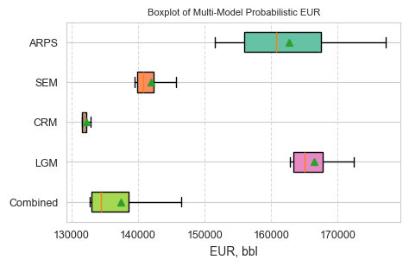

# 9. Conclusion

The multi-model probabilistic approach produces robust production forecasts and EUR estimates by integrating model uncertainty and measurement error.